**Liquid Nitrogen System**

Liquid Nitrogen is inert, colorless, odorless, and extremely cold that makes up 78% of the atmosphere. Nitrogen will not support combustion and is not life supporting. Below is table listing the physical and chemical properties of Liquid Nitrogen.

|  |  |
| --- | --- |
| **Chemical and Physical Properties** | |
| Chemical Formula | N2 |
| Molecular Weight | 28.01 |
| Boiling Point @ 1 atm | -320.5°F (195.8°C) |
| Freezing Point @ 1 atm | -346.0°F (210.0°C) |
| Critical Temperature | -232.5°F (146.9°C) |
| Critical Pressure | 492.3 psia (33.5 atm) |
| Density, Liquid | BP, 1 atm: 50.45lb/scf |
| Density, Gas | 68°F(20°C), 1 atm: 0.0725lb/scf |
| Specific Gravity, gas (air=1) | 68°F(20°C), 1 atm: 0.967 |
| Specific Gravity, liquid (water) | 68°F(20°C), 1 atm: 0.808 |
| Specific Volume | 68°F(20°C), 1 atm: 13.80scf/lb |
| Latent Heat of Vaporization | 2399Btu/lb Mole |
| Expansion Ratio, Liquid to Gas, BP to 68°F(20°C) | 1 to 694 |

**Health Hazards**

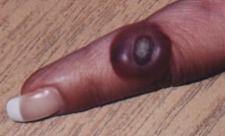Liquid Nitrogen is an inert, colorless, and odorless gas, it carries no visible warning properties; therefore humans have no way of detecting the presence. Cold Nitrogen vapors and exposure to liquid nitrogen can cause extensive tissue damage. A common example of extensive tissue damage is severe burns.

Another hazard of Liquid Nitrogen is asphyxiation or also known as oxygen deficiency, which occurs when there is a displacement of oxygen in the air with nitrogen to make the air insufficient to support life. Asphyxia develops when the when the oxygen content of air is below 20.5%. Effects of inhalation of oxygen deficient are as follows: dizziness, nausea, vomiting, loss of consciousness, and potentially death. Examples where oxygen deficient environments can occur include transferring between containers, leaking valves, liquid from tank venting, and from open containers.

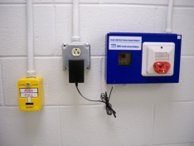A warning system commonly used for Liquid Nitrogen Systems are Oxygen Monitors, these are installed at each fill station on the ground, first, second, and third floors. If the oxygen level in the room drops below 19.5% the Oxygen Monitor’s red strobe will activate. If the oxygen level continues to drop and goes below 18.5%, the monitoring system will activate an audible alarm and send a signal to the central fire alarm control panel as a Level 2 alarm. The yellow strobe at the room will also begin flashing. Immediately leave the area. The alarm will silence once the oxygen level is at or above 19.5%.

**Personal Protective Equipment Required**

Proper personal protective equipment should be worn while operating the Liquid Nitrogen System. 0If a sufficient amount of liquid nitrogen comes in contact with the body results in a cold burn or also known as frost bite. Small amounts will evaporate and may only cause a small burning sensation similar to a pin prick. A danger can occur when large amounts of liquid nitrogen do not evaporate. When this occurs, take action immediately and evacuate the area. Care should be taken when using liquid nitrogen not to spill the liquid on clothing, since this can easily become saturated with the liquid and then hold it next to the skin for a significant period of time, leading to serious burns. The following are some precautions that can be taken:

* Wear personal protective equipment to keep smaller amounts from contacting the body.
* If a large spill occurs, discontinue filling and leave the room until the liquid evaporates.
* If clothing becomes soaked, hold it away from the body until it warms, or if a larger area is soaked, remove the clothing.
* If a cold burn occurs, once warmed up, it will appear very similar to, and should be treated the same as, a sunburn of comparable magnitude. Warm affected skin slowly using cold (NOT HOT) water.
* Any serious cold burn should be treated by a doctor

**Instructions on using 1st, 2nd, and 3rd Floor Fill Stations**

1. 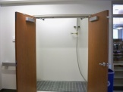Prop both Doors Open
2. Put on Personal Protective Equipment

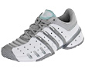

Closed Toe Shoes

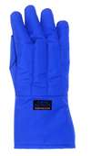

Cryo Gloves

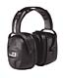

Ear Muffs

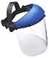

Safety Shield



Safety Glasses

**Note:** Long Pants, Lab Coats, or Protective Aprons are recommended.

1. After filling is complete, do not shut both doors immediately. Let the liquid nitrogen dissipate completely. Closing the door immediately will result in an oxygen deficient atmosphere in the closet causing the oxygen deficiency monitors to alarm.

**\*\*\*Solenoid will need to be turned on every morning and afternoon to keep the system cool at all times\*\*\***

**\*\*\* When filling hand dewars, users will need to make sure they do not completely empty them during liquid nitrogen use. When dewars are empty, it takes longer for liquid nitrogen to turn from its gas phase to liquid phase because the containers need to cool down first. Therefore, the first LN2 that dispenses into the containers evaporates to gas because the containers are hot in contrast to the LN2\*\*\***

**Transporting and Handling /Precautions**

Liquid nitrogen cylinders range in various sizes and weights. They are very heavy and cumbersome to move especially when filled. They should be handled by two people and with proper shoes. Be careful to avoid crushing hands or fingers between vessels or car and walls or door frames. The best way to transport Dewars inside buildings are as followings: for 4L Dewars should have handles and the large dewars should be on wheels. When transporting short distances in hallways the following precautions should be taken: the dewar should be your only load, it should have a venting lid, be careful to watch for people to run into you, and carry with both hands and as far away from your face as possible.Please be sure to avoid rough handling of containers and do not be leave containers unattended at anytime. Cryogenic Liquid cylinders should be moved with proper equipment.

**Filling Hazards**

Do not fill dewars or secondary containers of liquid nitrogen more than 80% capacity because expansion of gases may cause pressure build up. When working with liquid nitrogen make sure to work in well ventilated areas because high concentrations of escaping gas should not be allowed to collect in enclosed areas.

**Types of Liquid Nitrogen Containers**

Below are various pictures of different types of Liquid Nitrogen Cylinders and Dewars. 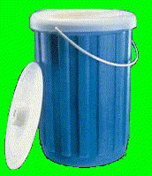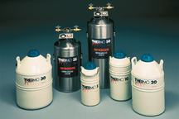

**Pressure Relief Devices**

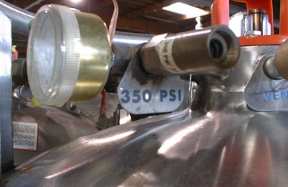 All Liquid cryogenic cylinders have pressure relief values. They are a control valve used to regulate the pressure in the tank. If gas product is not used, pressure will build until it is released by this control value. Hearing a slight hiss from a liquid cryogenic cylinder is a normal operation of its pressure relief device. Therefore, they should be stored in areas that are well ventilated. All cryogenic liquid must be stored in approved containers and stored in upright positions. One should never attempt to cap or seal a pressure relief device. The liquid to gas conversion rate is 2.3% per day under perfect conditions so the actual vaporization rate experienced will vary. Pressure relief devices are prescribed based on the following formula: Maximum Pressure Relief Device Rating = (Cylinder Service Pressure X 1.25) -15psi

**Precautions and Warnings**

Precautions and handling should be taken when working with liquid nitrogen system. Transferring of liquid nitrogen into containers must be done slowly to prevent thermal shock. Before use of liquid nitrogen cylinders, be sure to ensure that the fittings on the regulator match the fittings on the liquid container. Users should never attempt to change or remove any fittings. Users should never adjust, block, or attempt to repair anything on a liquid cryogenic cylinder. If ice or frost builds up on pressure relief devices, it can be removed with a damp cloth but proper PPE should be worn (See Section Personal Protective Equipment required).

1. **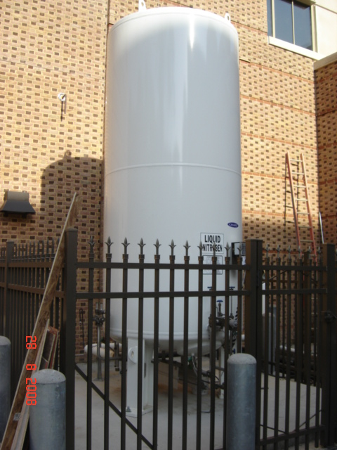

   **Safety Valves**

   **Shut Off Valve**

   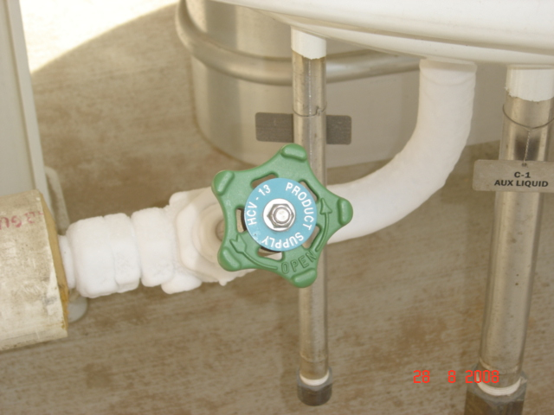

   **LN2 Shut Off Valve**

   IV. HOW TO STOP LIQUID NITROGEN FLOW INTO THE ISC BUILDING**
2. The shut off valve that stops the flow of liquid nitrogen through the piping and into the ISC building is located on the Landrum Drive-side of the liquid nitrogen storage tank.
3. Use the New GGM key #987XXX to open the padlock on the fence gate to gain access to the valve. [Note: The valve is labeled with a plastic name plate suspended by a chain that is hung over the valve stem.]
4. Be sure you are wearing safety glasses, a faceshield, blue cryogen gloves and closed-toe shoes. Safety equipment is located in Room 0032. The New GGM Key #987XXX opens the Room 0032 door.
5. Turn the valve clockwise to close.

**In Case of A Liquid Nitrogen (LN2) Release or Emergency**

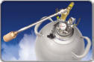**IN CASE OF A Liquid Nitrogen (LN2) Release or Emergency**

The LN2 supply is piped into the ISC building and dispensed from one of 4 locations: Rooms 0024, 1024, 2020, and 3022. The dispensing stations on the 1st, 2nd, and 3rd floors are manually operated and require the person filling the container to periodically stop filling and check the liquid level in the container. The flooring inside the LN2 dispensing station consists of a metal grate and secondary containment to catch spillage that occurs in the filling process. The dispensing station on the ground floor is automated and will shut off when the system senses the container is full. Personal Protective Equipment (PPE) is provided at each dispensing station. PPE consists of a faceshield, cryogen gloves and hearing protection. An additional set of cryogen gloves and faceshield is located in Room 0032 for use by emergency responders. The key to Room 0032 is either the building master “J” key or the new grand master #987XXX. Keys are located in the Knox Box.

There are four likely scenarios leading to a LN2 spill. The first two would be a break/leak in the piping system or an equipment failure that causes the LN2 to warm to a gas. The third scenario for a LN2 release would be a LN2 container failure. The final scenario would be an overturned LN2 container.

**LN2 ALARM**

* The LN2 dispensing stations are each equipped with an oxygen sensor that will detect an oxygen deficient atmosphere inside the dispensing room/closet. The sensor will activate audible and visual alarms. If you are outside the dispensing station when it goes into alarm, DO NOT ENTER THE LN2 ROOM/CLOSET. Call the Primary Contact person listed on the Door Hazard sign posted at the entrance to the dispensing room/closet.
* If you are inside the LN2 dispensing room/closet when the system alarms, evacuate immediately. Close the door behind you if possible and call the Primary Contact. If you are unable to determine who the Primary Contact person is, notify the W&M Police Dispatch and request assistance.

**MAJOR LN2 RELEASE**

* If there is a major release of LN2 from the piping system, there will be an obvious white plume. LN2 is heavier than air so the plume will tend to drop to the floor. The visible plume is water mist that has condensed from the humid air as it is cooled by the escaping LN2. As the LN2 warms up, it will turn to nitrogen gas. Nitrogen gas is a non-toxic, colorless, odorless, non-flammable gas. It is a simple asphyxiant and can cause serious injury and death.
* Keep the door closed to the dispensing room/closet if possible.
* Evacuate the area and maintain good ventilation and/or local exhaust.
* **

  **Main Shut Off Valve****To stop the flow of LN2 in the piping system, close the main shut off valve located outside at the LN2 storage tank.
* The LN2 in the piping system will gradually warm up and release through the breach in the piping and through the roof vent.
* Contact Work Control to request repair to the piping system.
* Notify the Director, EH&S at 221-2146.
* If you or someone else is injured during the release, relocate them to fresh air. Call 911.

**MINOR LN2 RELEASE**

* Minor releases of LN2 come from containers with a finite quantity of LN2. If there is a breach in a container, relocate the container into a fume hood or near a local exhaust snorkel and allow it to ventilate until the LN2 is gone. Do this only if you can move the container safely. Ensure you are wearing a protective faceshield, closed-toe shoes, and cryogen gloves.
* If you can not move the container safely, then evacuate the room and close the door behind you. Post a sign on the door alerting others not to enter.
* Call EH&S. They have portable oxygen sensors and can monitor the area. They will notify you when it is safe to re-enter.
* If you attempt to relocate a leaking dewar to the outdoors, you must ensure that you alert personnel along the exit path to evacuate before you attempt to move the dewar. Carry a cell phone with you in case you need to call for help.
* DO NOT USE THE ELEVATOR TO RELOCATE A LEAKING DEWAR TO THE OUTDOORS. Instead, leave the dewar in place and evacuate the area.
* Notify the Director, EH&S at 221-2146.

References:

* 1. Air Products/Safety Gram #7 : <http://www.airproducts.com/nr/rdonlyres/89de2726-10bb-4e89-94e9-62f11a23cfbc/0/safetygram07.pdf>
  2. University of Pennsylvania Office of Environmental Health and Safety: <http://www.ehrs.upenn.edu/resources/docs/labsafety/cryogen.pdf>
  3. Purdue University: <http://www.chem.purdue.edu/chemsafety/Chem/ln2.htm>
  4. Geneva: [www.ars.usda.gov](http://www.ars.usda.gov)